Date:15/11/22

**Practical-6**

**Aim:**

Reading material has title and price. A book is a reading material. It has ISBN number. A magazine is a reading material, it has month of issue. A CD is a reading material, it has duration in minutes. Represent the above description as a generalization, specialization tree. Identify the parent class, its attributes, child class and their attributes. Write all of them clearly.

**Theory:**

Generalization:

Generalization is the process of grouping entities into broader categories based on common attributes. The common attributes together form a higher-level component called a generalized entity. Two entity types in a university's database, for example, might be Students and Professors. The attributes related to Students could be name, phone number, nationality and GPA. For professors, they could be name, phone number, nationality and salary. The common attributes for both entities are name and phone number. Together, these combined attributes can create a generalized entity called Person. The uncommon attributes—GPA and salary—become separately associated with their respective entity types.

Generalization relationship is a relationship that implements the concept of object orientation called inheritance. The generalization relationship occurs between two entities or objects, such that one entity is the parent, and the other one is the child. The child inherits the functionality of its parent and can access as well as update it.

The generalization relationship is incorporated to record attributes, operations, and relationships in a parent model element so that it can be inherited in one or more child model elements.

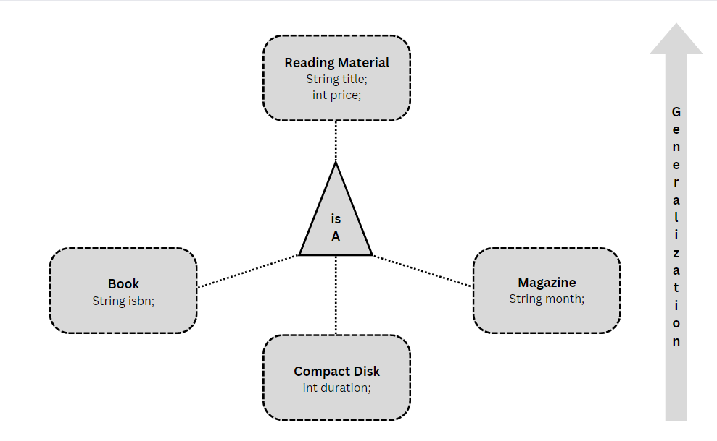

Specialization:

Specialization is the process of dividing a higher-level entity into narrower categories. Being the opposite of generalization, it requires the separation of entities based on uncommon attributes. For example, in a business's database, the Person entity type can be separated into Customers and Employees. The associated attributes for customers might be payment card information, email addresses and customer ID numbers. For employees, they might be wages and employee ID numbers. Both retain the attributes of their higher-level ordering, allowing them to be found by attributes such as name and address.

Specialization is a top-down approach, and it is opposite to Generalization. In specialization, one higher level entity can be broken down into two lower level entities.

Specialization is used to identify the subset of an entity set that shares some distinguishing characteristics.

Normally, the superclass is defined first, the subclass and its related attributes are defined next, and relationship set are then added.

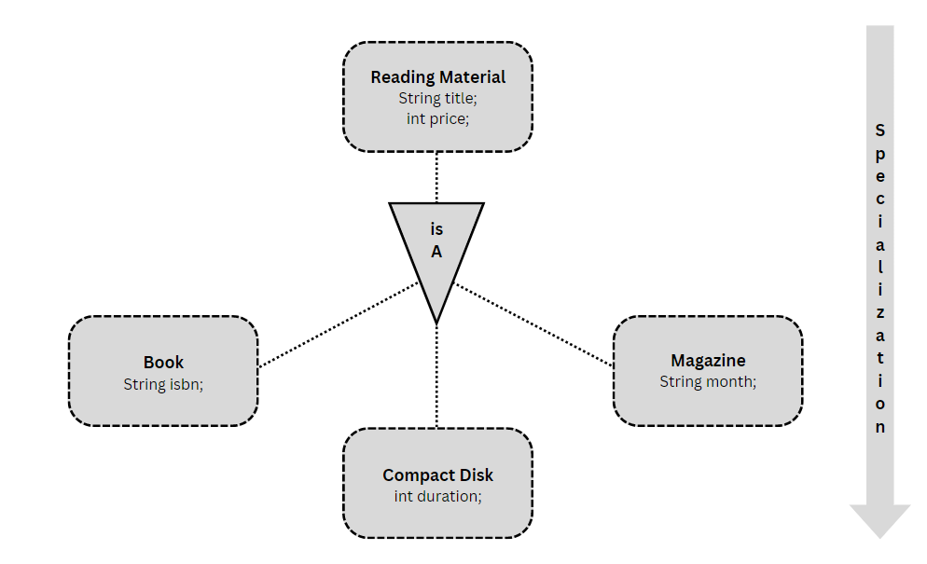

**Result:**

We have successfully identified Generalized and Specialized Class.